Operating systems

LAB # 01

# ***Task #1***

## Steps:

1. File created with “nano file1.txt”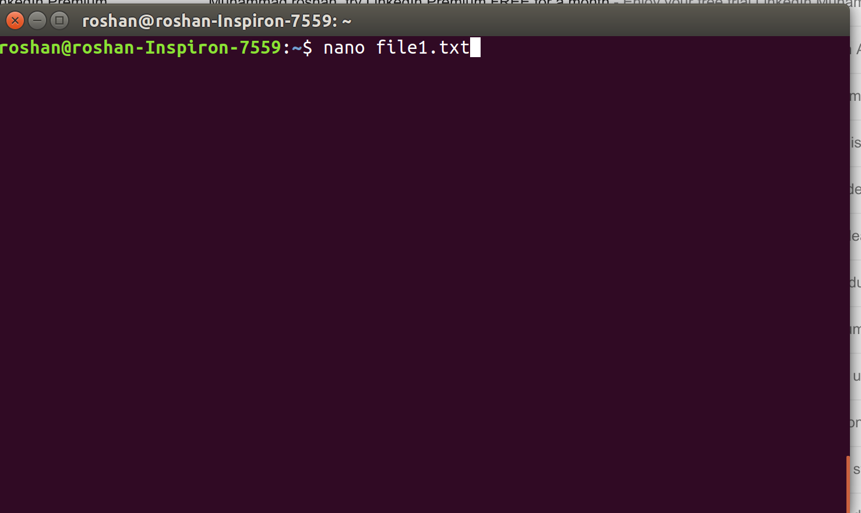
2. In nano editor, wrote some text.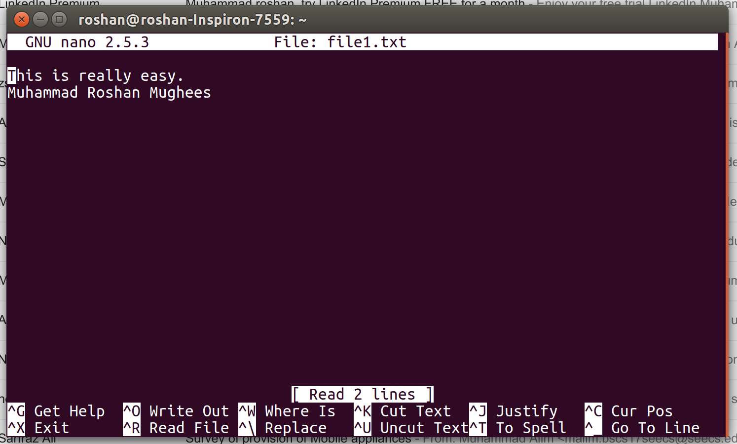
3. Created file2 and read file “file1.txt” using ctrl+R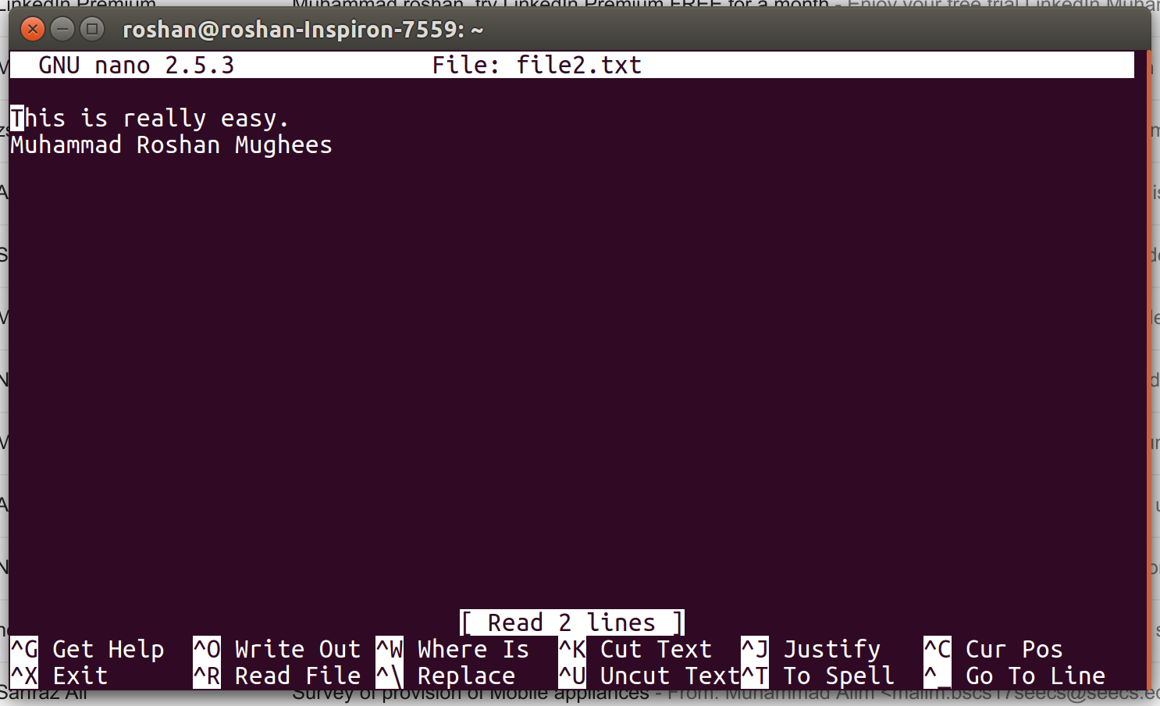
4. 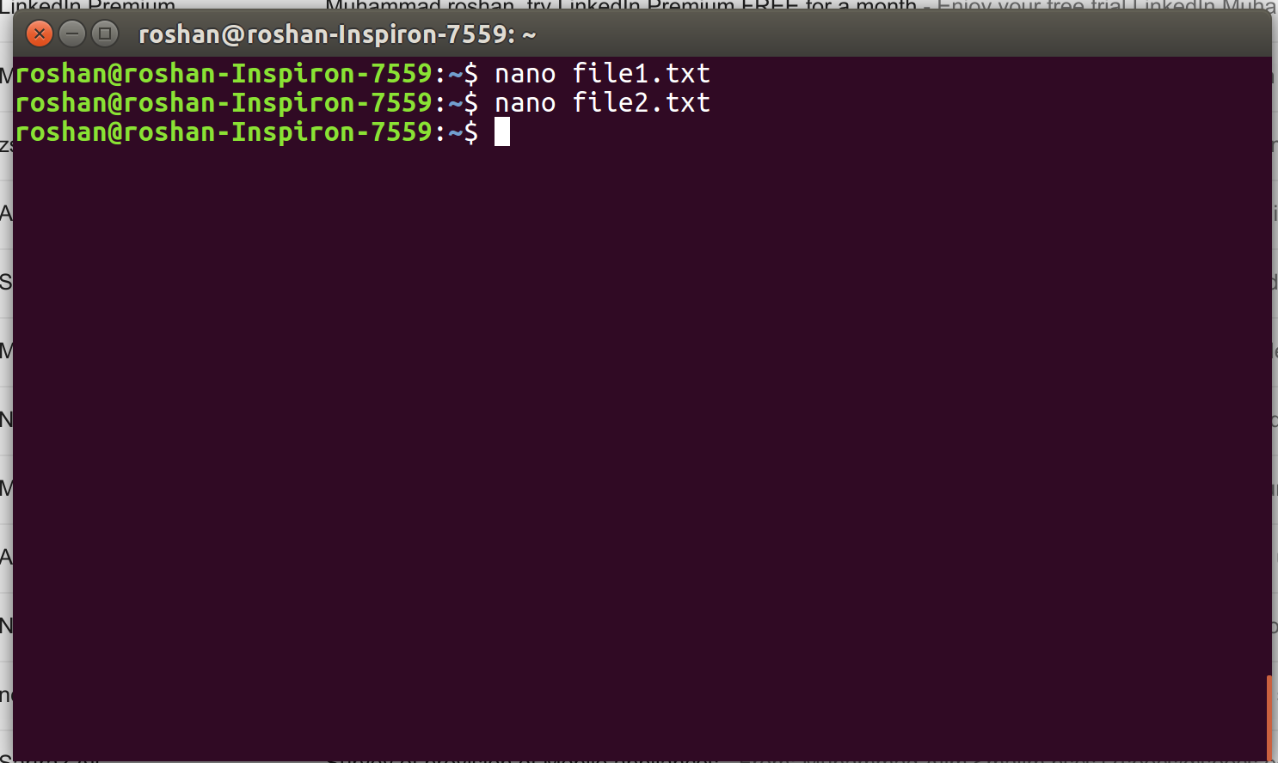Then “file2.txt” is saved with ctrl+o and closed with ctrl+x

# ***Task #2***

## Steps:

Method 1

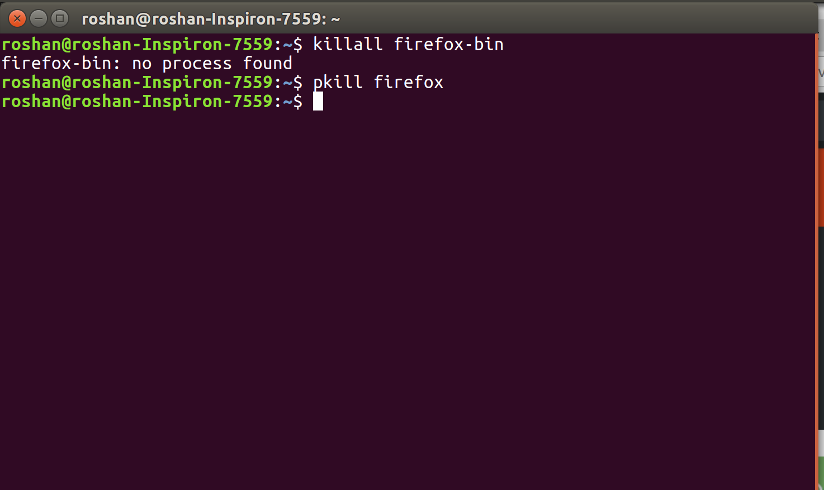

Method 2

1. Start gnome system monitor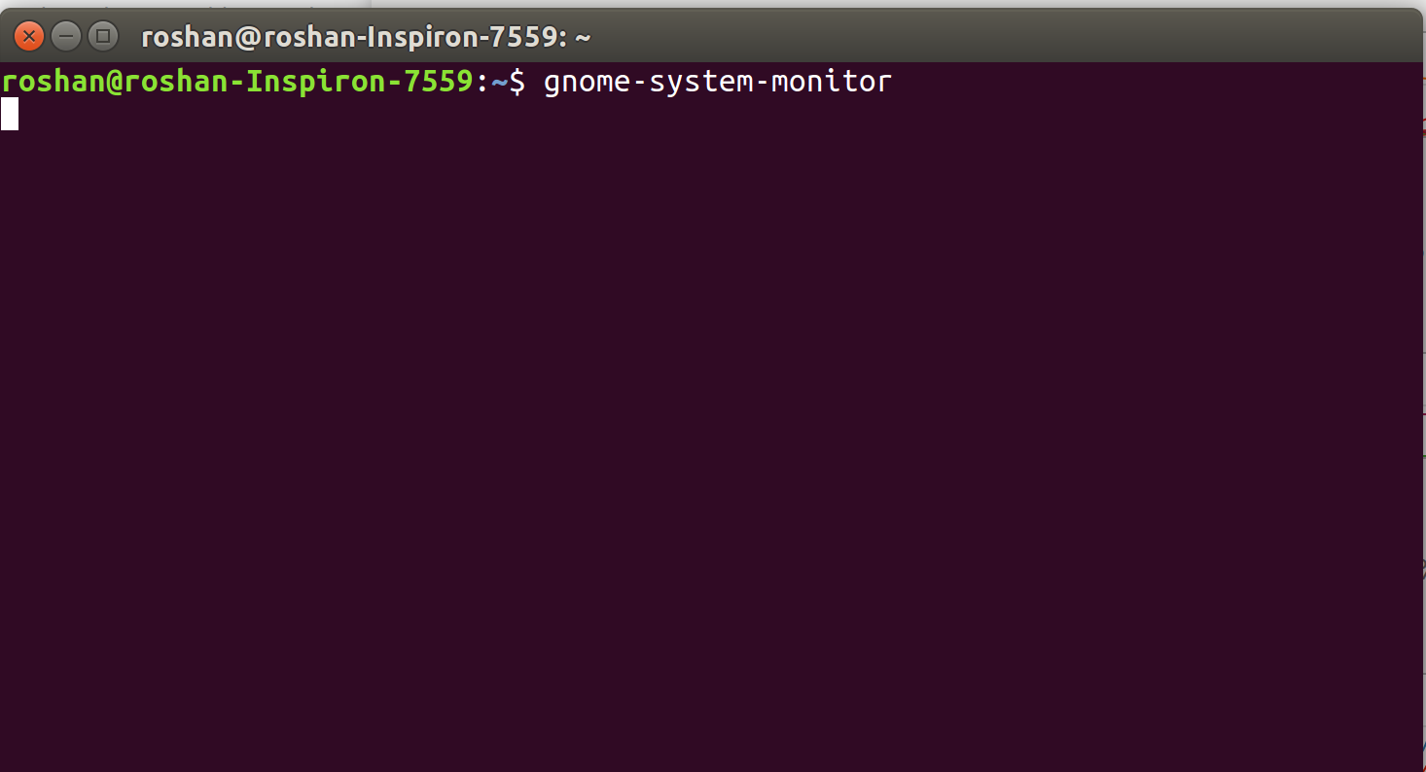
2. Kill chrome/firefox from it.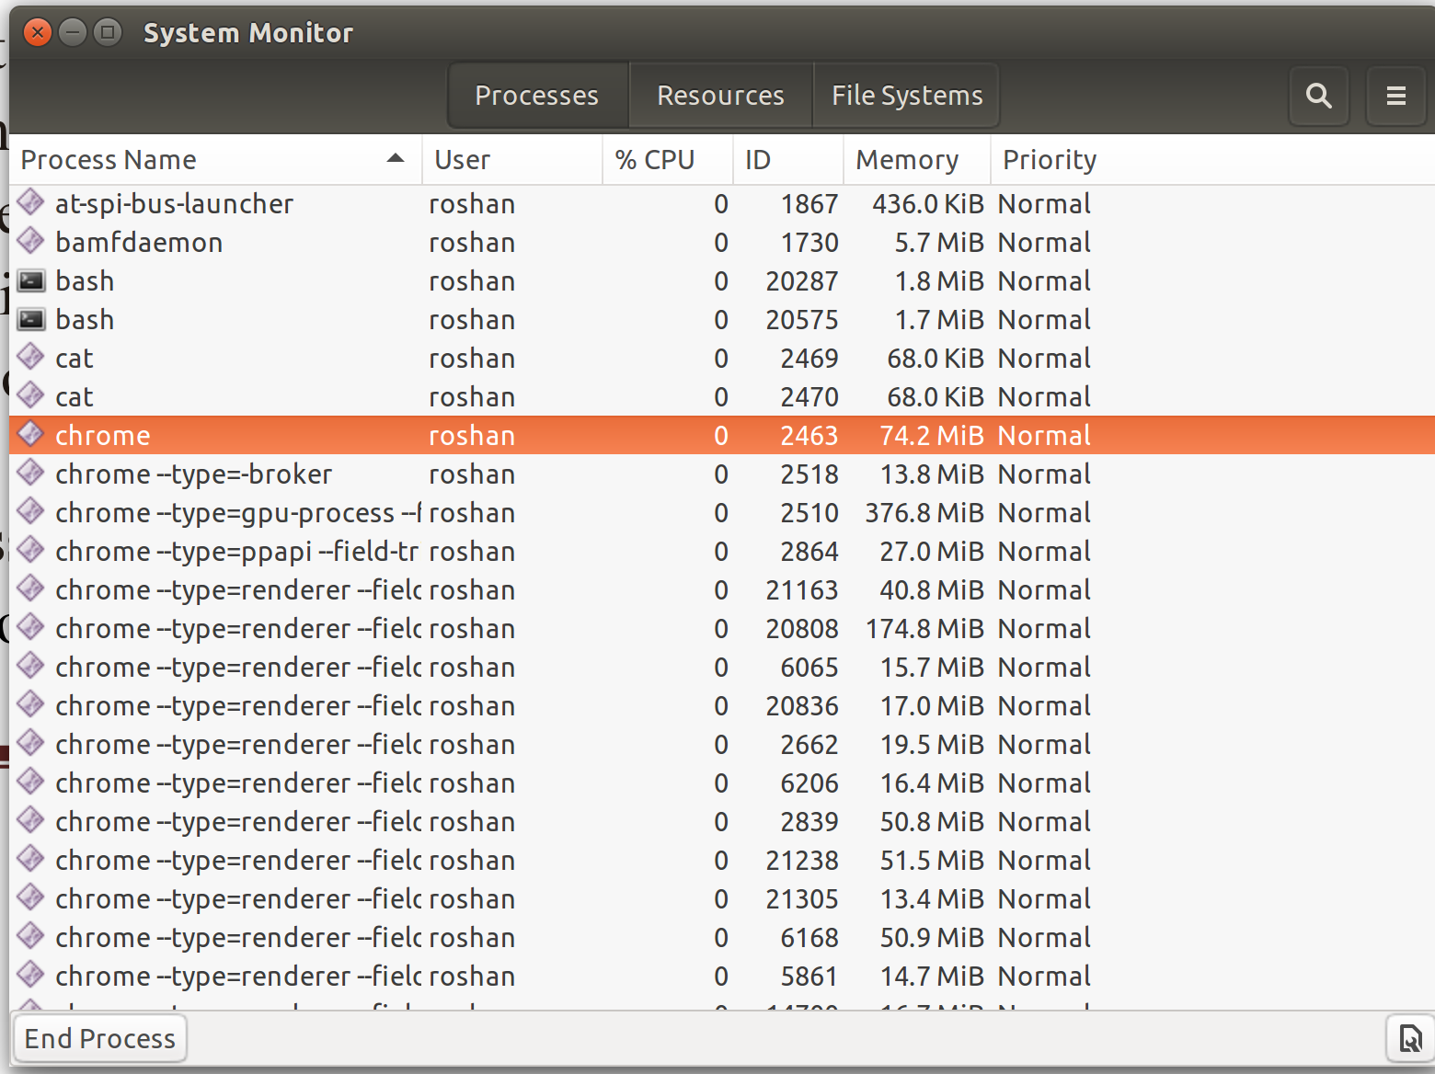

# ***Task #3***

Steps:

1. “mkdir” can be used to make a new directory.
2. Move file1.txt by “mv file1.txt dir1/”
3. “mkdir dir2” for creating a new directory after going back by “cd ../”
4. And again move that file by using “mv” command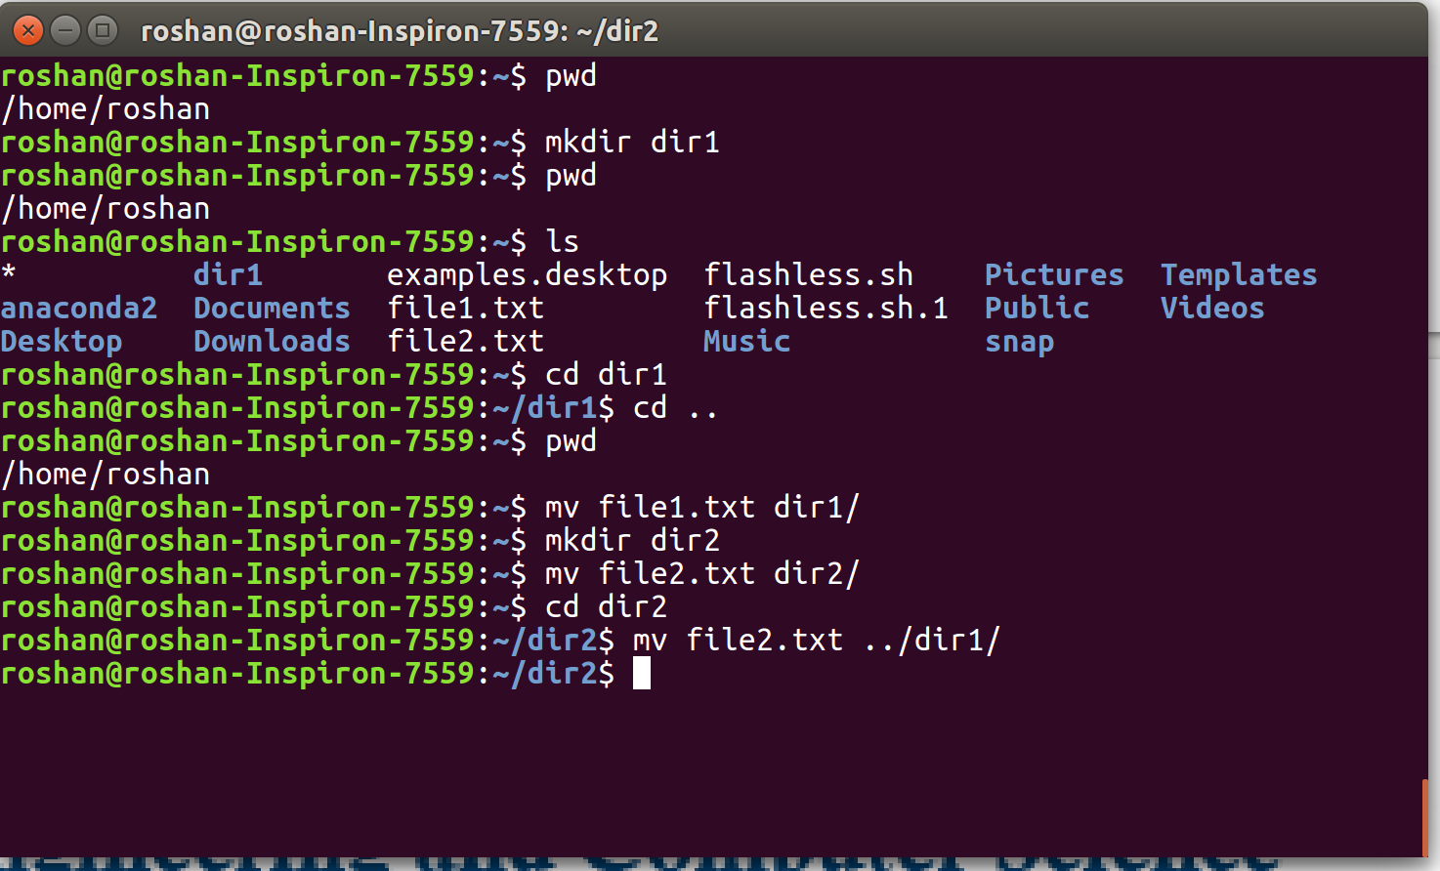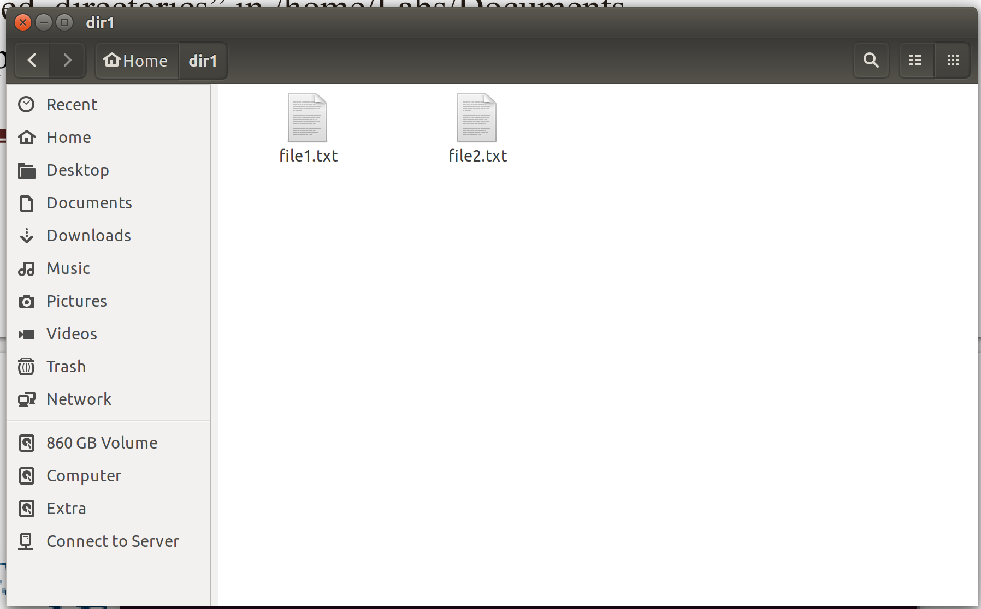

***Task #4***

Steps:

1. Move dir1 and dir2 to a new folder
2. Zip the file by using “zip -r filename.zip foldername_to_be_zipped”

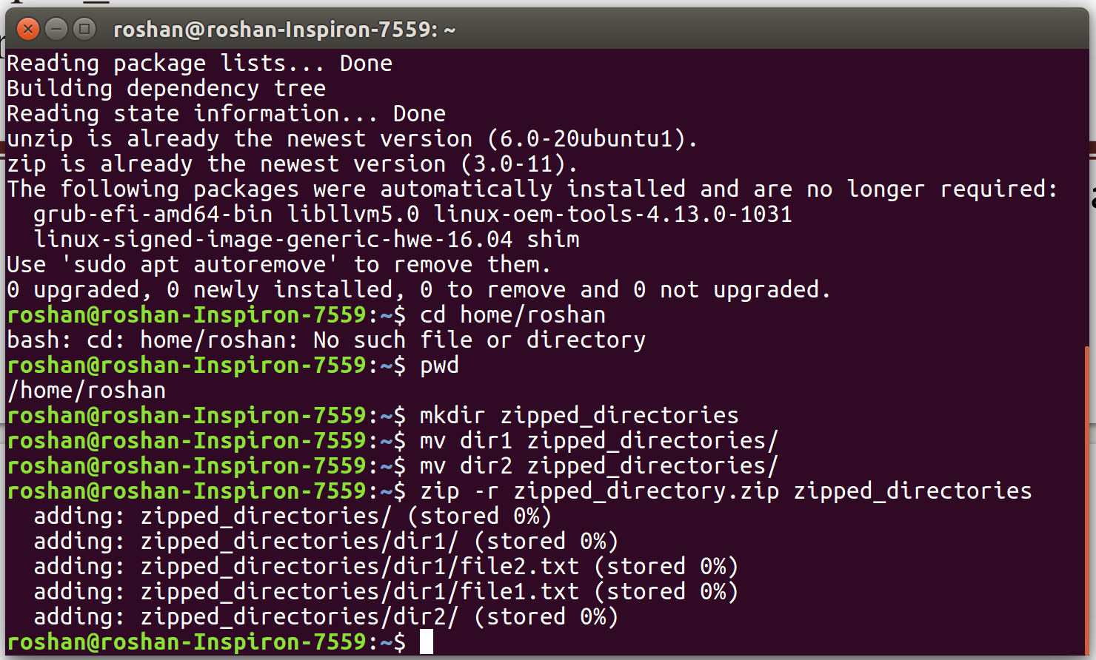

***Task #5***

Steps:

1. Make a new folder named labs using “mkdir” and make another folder of documents in it
2. Use command “unzip path/of/file” for unzipping the file here

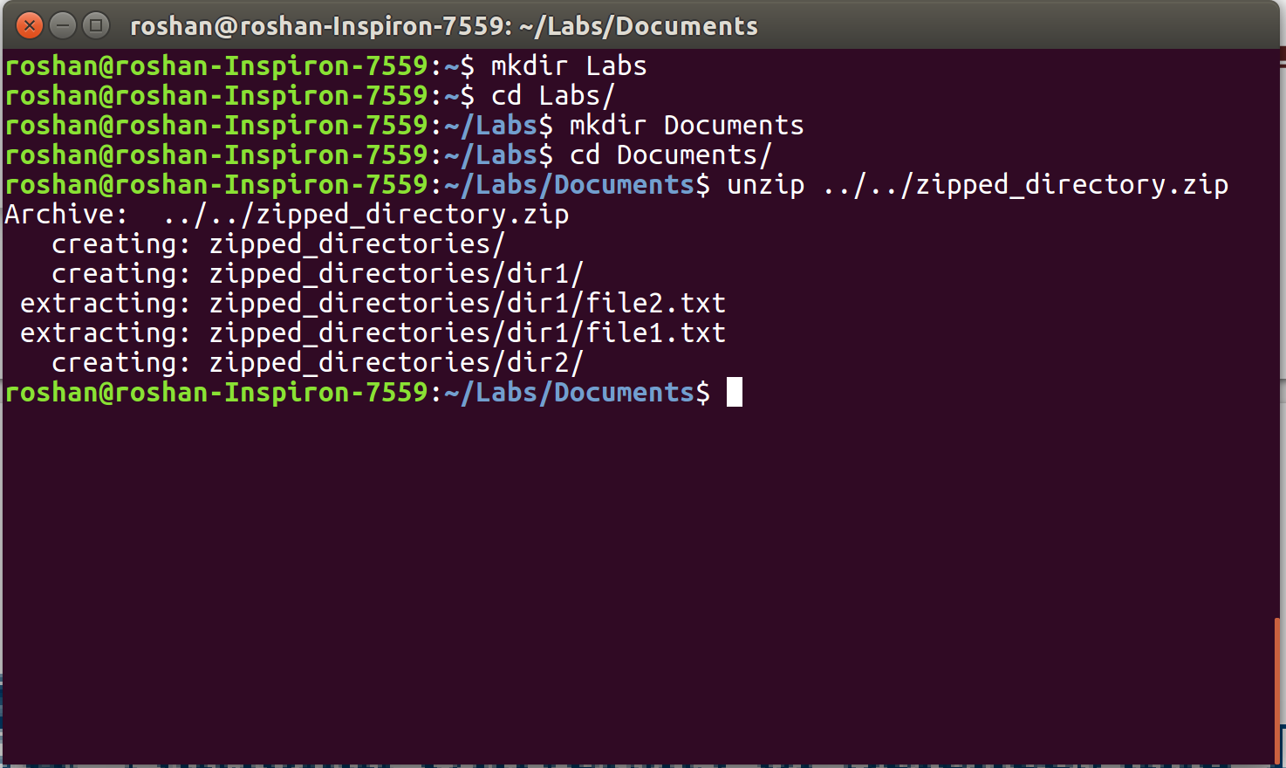

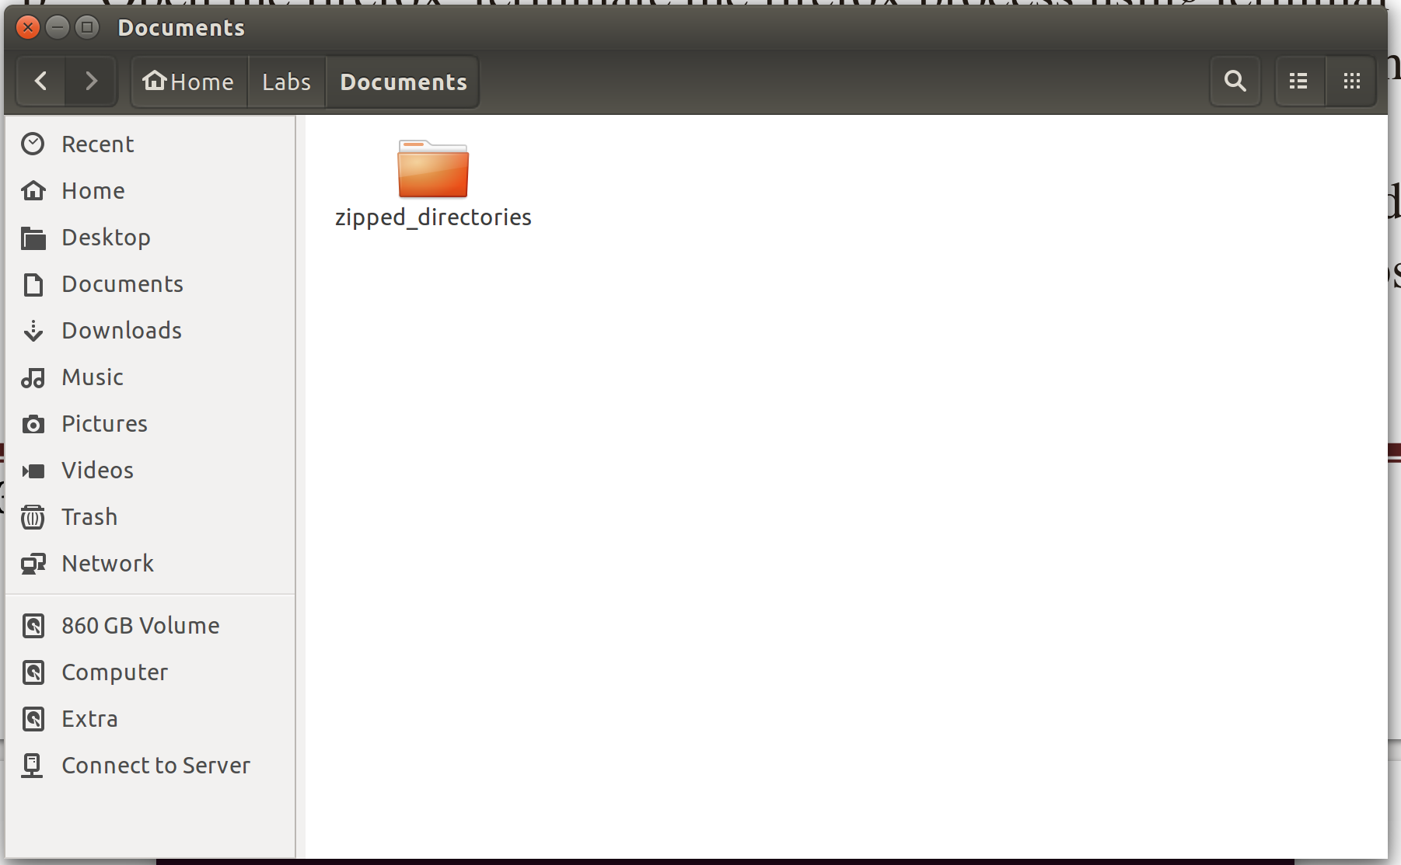

***Tasks #6:***

Steps:

1. Using Nano editor make a new file and copy paste the script provided

